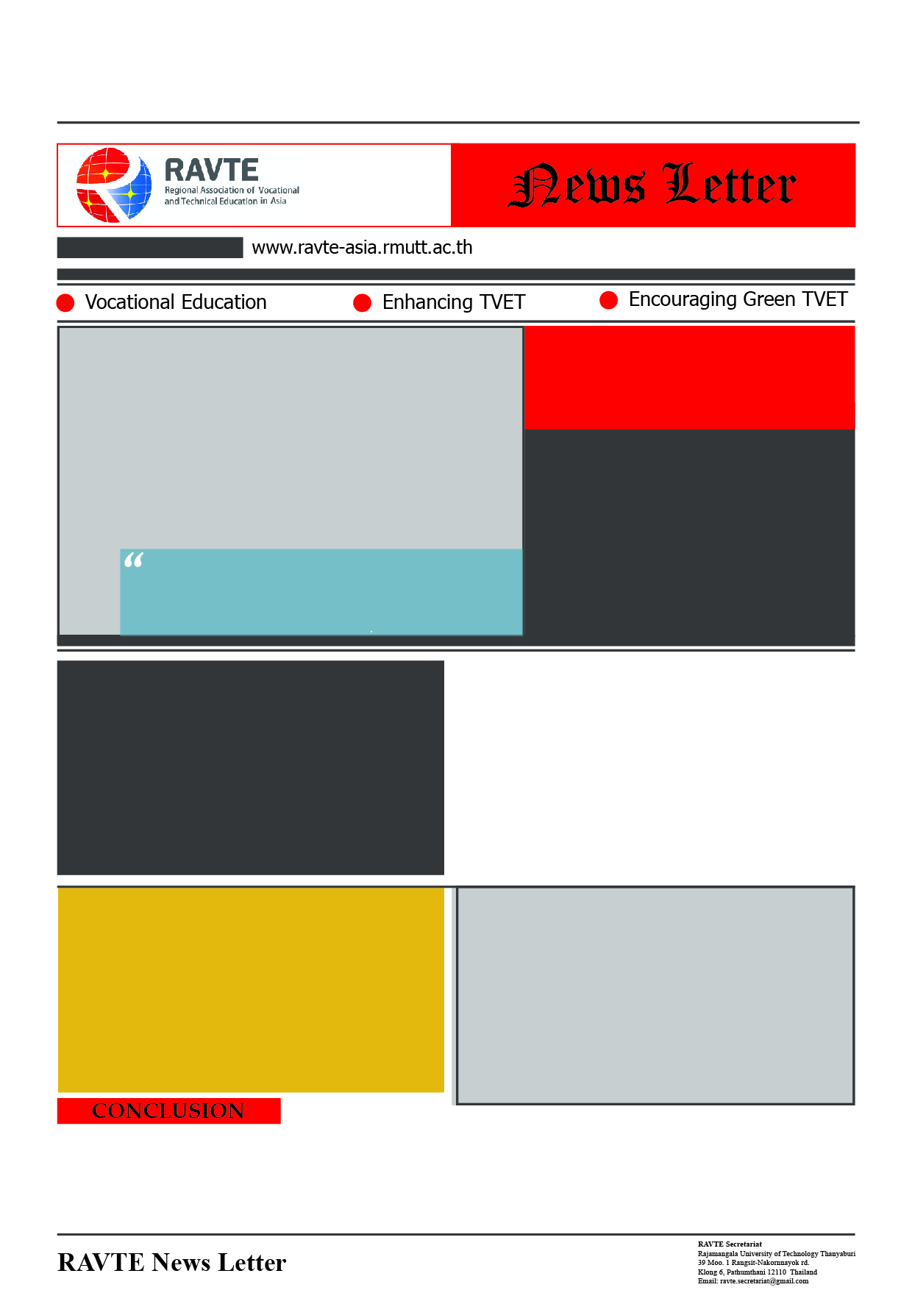–

Content

Header

Picture

Content

Header

Content

Header

Content

Content

Header

Content

Picture